Replacing the Elevator Rod Guide

NEVER STAND IN FRONT OF A TRAP MACHINE. THE TRAP MACHINE MUST BE TURNED OFF AND THE SPRING RELEASED BEFORE ENTERING THE TRAP HOUSE. NEVER ATTEMPT TO MAKE ANY ADJUSTMENT WHILE THE THROW ARM IS COCKED.

- The machine must be released and turned off before beginning work.
- Turn the machine on for ¼ second and them immediately off. This will allow the elevator to go up without the throw arm re-cocking.
- Remove the two rod guide bolts.
- It is important to remember the orientation of the rod guide. (right side up and front to back.)

Left bolt is short bolt 1/4x28x3/4 Right bolt is the long bolt 1/4x28x7/8

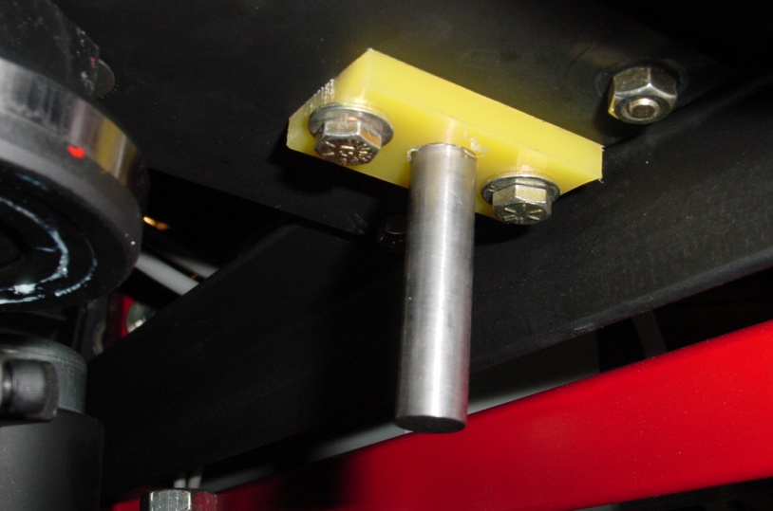
Elevator Rod Guide plastic
Stainless Steel Elevator Rod
Elevator Rod Guide

Front of machine
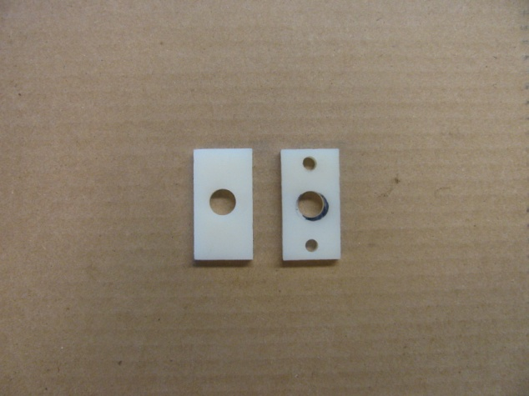
“Worn side”

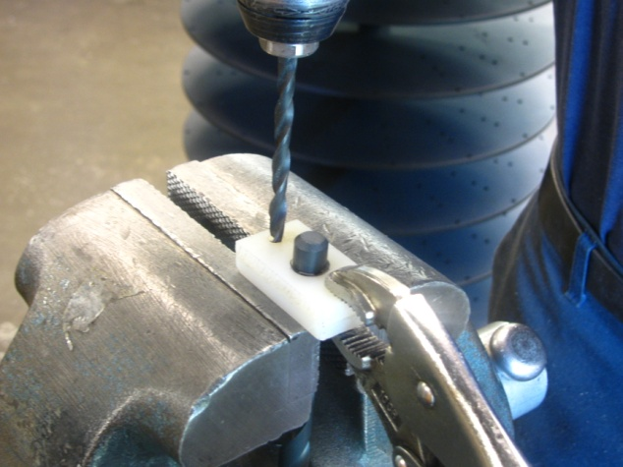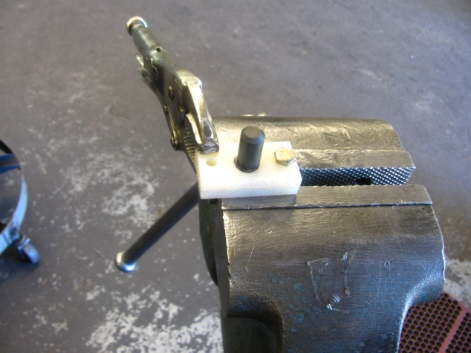
Hole #1 Hole #2

- Use a ½” drill (as pictured) and place the old guide on top of the new guide.
- Notice that one side of the hole in the old guide will be elongated from wear. Set the “unworn” side of the hole against the drill shaft and square the ends and clamp with a vise-grip, as pictured.
- Use a ¼” drill and drill the first hole.
- Put a bolt through the first hole and drill the second hole.
- Mark the new rod guide so that you can remember its orientation and install accordingly.

